# Shell code

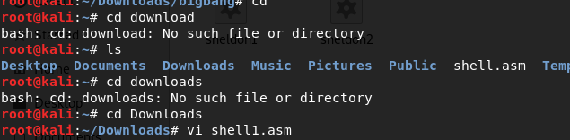

Write a shell code to get out put ‘Y’

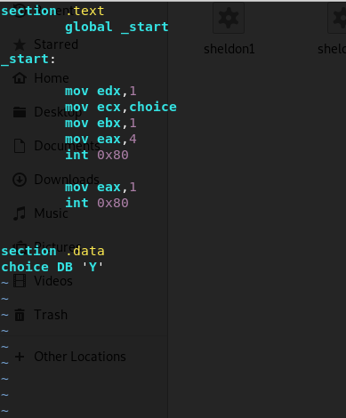

To compile it use the following commands:

nasm -f elf -o shell.o shell.asm

ld -o shell shell.o

Now run it with:

./shell

to extract the shellcode.

objdump -M intel -d shell

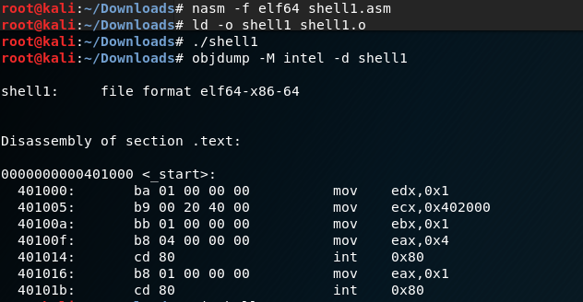

Shell code

“\xba\x01\x00\x00\x00\xb9\x00\x20\x40\x00\xbb\x01\x00\x00\x00\xb8\x04\x00\x00\x00\xcd\x80\xb8\x01\x00\x00\x00\xcd\x80”